2023 Leader Effectiveness Training
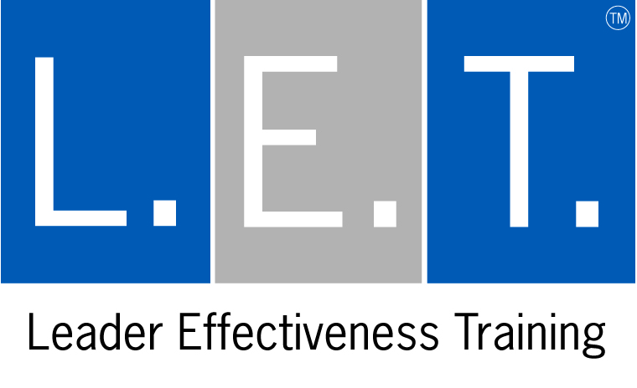
Workshop Registration Form
Workshop City: Dates:
1. CITY AND DATE OF L.E.T. WORKSHOP:

2. YOUR INFORMATION: 3. INVOICE INFORMATION (If different):

Name:
Title:
Company:
Address:
City, State, Zip:
Tel:
Email:

Name:
Title:
Company:
Address:
City, State, Zip:
Tel:
Email:
4. WORKSHOP PAYMENT:

Tuition is $1,795 and is due prior to workshop. Please select method of payment below--if paying by credit card, we accept Visa and MC - please provide the corresponding billing address in the area above [right], if different. If paying by check, please mail it with your registration form to GTI: 531 Stevens Ave West, Solana Beach, CA 92075 - Tuition includes: Workshop and L.E.T. Participant Set—shipping is additional.
Credit Card #: Exp: Sec. Code:

Total # attending workshop: Total tuition $:

(Each participant needs their own registration form)

5. ABOUT THE WORKSHOP AND MATERIALS:

Materials you will receive: L.E.T. text, “Intro to L.E.T.” Packet (emailed ahead of time), L.E.T. Participant Workbook, Credo, Desk Top Reminder, Wallet Card and Participant Certificate. We ship these to you ahead of time. At the workshop, you can also sign up for a free monthly blog called the “L.E.T. Connection.” This blog consists of helpful reminders, tips and ways to reinforce your L.E.T. skills.

6. ABOUT YOU:
1. What is your job function and what is prompting you to attend the L.E.T. Workshop?

2. Are you attending the L.E.T. Workshop to (please circle/highlight your answers):

- become an L.E.T. Facilitator? Yes No
- preview the workshop before you schedule an On-Site Workshop or certify In-House Facilitators at your company? Yes No
- experience the Workshop for personal and professional growth? Yes No

3. So that we can keep in contact with you should you make a career change, please provide us with an alternative email address. (NOTE: we will always keep your information confidential.) Alternative email address:

4. How did you hear about L.E.T.? Please be as specific as possible:

7. EMAIL US THIS REGISTRATION FORM: workplace@gordontraining.com

We will confirm receipt of it, confirm your attendance and email you a confirmation letter with workshop details. Please phone
Michelle Adams at 800.628.1197, ext. 308, at GTI (Gordon Training International) with any questions. Thank you! ☺

